Name_________
Surname___________
Group_______________
The 19th of January.
Great Britain
- Read the words;
The United Kingdom of Great Britain and Northern Ireland, the British Isles, Great Britain, England, Scotland, Wales, Northern Ireland, London, Edinburgh, Cardiff, Belfast, Birmingham, Liverpool, Manchester, Glasgow, the Thames , the European continent, the North Sea, the Straits of Dover , the English Channel, the Atlantic Ocean, the Irish Sea, the North Channel, the St. George's Channel
- Write down the words -with the sound [ ae]
- Write down the words with the sound [аi]
- Write down must read the words with article
- Write down must read the words without article

2.You should odd one word out.
- Edinburgh, London, Liverpool, Belfast.
- Scotland, Cardiff, England, Wales.
- Russian, English, Scottish, Welsh.
- The Thames, the Severn, the Mississippi, the Avon.
- The Atlantic Ocean, the Yellow Sea, the North Sea, the Irish Sea.
Fill in the gaps using your knowlage
country | capital | official language | total area | population | flag | emblem
England

Scotland
Wales
Northern Ireland

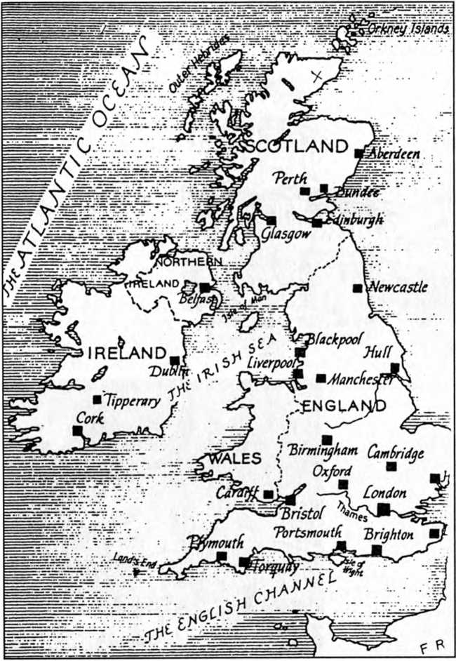

The United Kingdom of Great Britain and Northern Ireland (the UK) occupies a territory of the British Isles (5,500 islands) with the total area of 244,100 sq km. The UK is situated off the northwestern coast of Europe between the Atlantic Ocean and the North Sea. It is separated from the Continent by the English Channel and the Strait of Dover. The UK is also washed by the Irish Sea, the St George’s Channel and the North Channel. Surrounding the British Isles by the water has been an important protection against the invaders throughout the English history. And certainly, it influences the climate of the country.
The UK consists of four parts and every part has its national emblem: England — the red rose, Scotland — the thistle, Wales — the daffodil and the leek, Northern Ireland — the shamrock. The capitals of the four parts are London, Edinburgh, Cardiff and Belfast respectively.
One can’t describe the country without mentioning its surface. The island of Great Britain can be divided into two main regions: Lowland Britain and Highland Britain. Lowlands comprise southern and eastern England. Highlands include Scotland, Wales, the Pennines, the Lake District and the southern peninsula of Britain. Many rivers are flowing through Great Britain, such as the longest Severn with its tributaries, the swiftest Spey, the busiest Thames etc. All parts of Great Britain are worth seeing.
The population of the UK is over 57 million people. The official language is English, but some people continue speaking their mother tongue: Scottish in Western Scotland, Welsh in northern and central Wales and Irish in Northern Ireland.
The flag of the UK is made up of three crosses of the patron saints: the upright red against a white background — St George of England, the white diagonal against a blue background — St Andrew of Scotland, the red diagonal against a white background — St Patrick of Northern Ireland. The English people have the habit of naming their national flag “the Union Jack”.
The UK is a constitutional monarchy. The Head of the State is the Queen who reigns with the support of Parliament.
For a long time the UK has succeeded in remaining one of the important commercial centres of the world. Nowadays the UK doesn’t depend upon economics and industrial manufacturing of other countries.
- Learn new words, transcribe them
To appoint -назначать
to determine- определять
to revise- пересматривать
to examine- рассматривать
to vote- голосовать
to sign- подписывать
to make laws- издавать законы
to approve- одобрять
a legislative branch- законодательная власть
an executive branch- исполнительная власть
judicial branch- судебная власть
a house- палата
a representative- представитель
majority- большинство
Read the text.
Political System of Great Britain
Answer the questions:
- What kind of state is the UK?
- Who is the head of the state in the UK?
- What are the Houses of the British Parliament?
Read the text and check your answers.
The United Kingdom of Great Britain and Northern Ireland is a constitutional monarchy. It means that the sovereign reigns but does not rule.
Britain does not have a written constitution, but a set of laws.
Parliament is the most important authority in Britain. Technically Parliament is made up of three parts: the Monarch, the House of Lords; and the House of Commons. In reality the House of Commons is the only one of the three which has true power.
The monarch serves formally as head of state. But the monarch is expected to be politically neutral and should not make political decisions.
The present sovereign is Queen Elizabeth II. She was crowned in Westminster Abbey in 1953.
The House of Commons consists of Members of Parliament. There are 650 of them in the House of Commons. They are elected by secret ballot. General elections are held every five years. The country is divided into 650 constituencies. All citizens aged 18 and registered in a constituency, have the right to vote. But voting is not compulsory in Britain. Only persons convicted of corrupt and certain mentally ill patients don't take part in voting.
There are few political parties in Britain thanks to the British electoral system. The main ones are: the Conservative Party, the Labour Party and the Liberal / Social Democratic Alliance.
Each political party puts up one candidate for each constituency. The one who wins the most votes is elected MP for that area.
The party which wins the most seats in Parliament forms the Government. Its leader becomes the Prime Minister. His first job is to choose his Cabinet. The Prime Minister usually takes policy decisions with the agreement of the Cabinet.
The functions of the House of Commons are legislation and scrutiny of government activities. The House of Commons is presided over by the Speaker. The Speaker is appointed by the Government.
The House of Lords comprises about 1,200 peers. It is presided by the Lord Chancellor. The House of Lords has no real power. It acts rather as an advisory council.
It's in the House of Commons that new bills are introduced and debated. If the majority of the members are in favour of a bill, it goes to the House of Lords to be debated. The House of Lords has the right to reject a new bill twice.
But after two rejections they are obliged to accept it. And finally a bill goes to the monarch to be signed. Only then it becomes law.
Parliament is responsible for British national policy. Local governments are responsible for organizing of education, police and many others.
Decide if the sentences are true, false or not stated.
1. British Constitution is one of the oldest in the world.
2. The House of Commons has the real power in the country
3. The Monarch was responsible for political decisions till the 20-th century.
4. The present Monarch was crowned in Buckingham Palace.
5. Members of the House of Commons are elected every five years.
6. Citizens have the right to vote at the age of 18.
7. The Conservative Party has the majority in the Parliament.
8. The Prime Minister is the leader of the party which wins the most seats in Parliament.
9. The Speaker is chosen by the Members of Parliament.
10. The House of Lords acts as an advisory council.
11. A bill becomes law after it is accepted in the House of Lords.

