The 20th of January
FAMILY RELATIONSHIPS
Learn The Words
Слово | Перевод
aunt | тетя
baby | малыш, младенец
brother | брат
boyfriend | парень, любимый, молодой человек
bride | невеста
cousin | двоюродная сестра
dad | папа
daughter | дочь
father | папа
father-in-law | тесть, свекор
fiancé | жених
fiancée | невеста
friend | друг
girlfriend | любимая девушка
godchild | крестница
godfather | крестный отец
godmother | крестная мать
grandchild | внук, внучка
grandchildren | внуки
granddaughter | внучка
grandfather | дедушка
granddad | дедушка
grandpa | дедушка
grandmother | бабушка
grandma | бабушка
grandson | внук
great-grandparents | прабабушка и прадедушка
groom | жених
half-brother | сводный брат
husband | муж
mother | мама
mother-in-law | теща, свекровь
mum | мама
mummy | мама
mom | мама
nephew | племянник
niece | племянница
parent | родитель
sister | сестра
son | сын
stepbrother | сводный брат
twin | близнец
twin-brother | брат-близнец
uncle | дядя
wife | Жена
adult | взрослый
bachelor | холостяк
child | ребенок
couple | пара
kid | ребенок
elder | старший
spinster | старая дева
to adopt | усыновить, удочерить
to be divorced | быть разведенным
to bring up | воспитывать
to raise | воспитывать
wedding | свадьба
youth | молодежь
REVISE THE IDEOMS
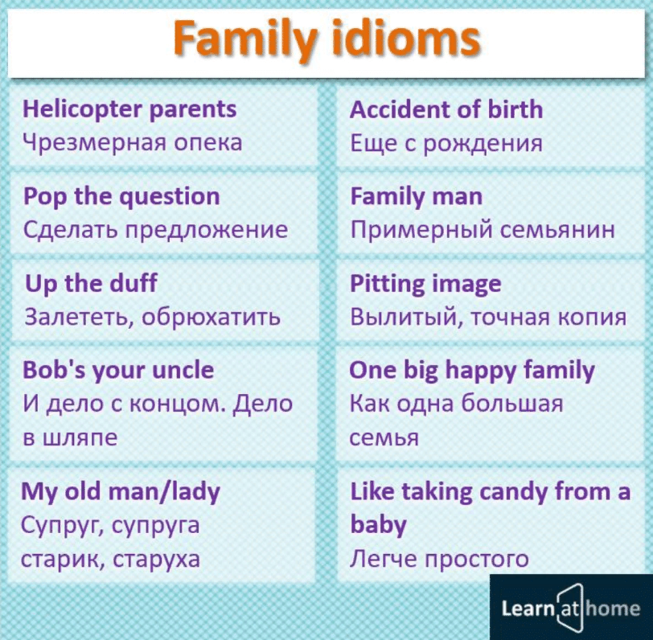
Exersice 1. Вставьте подходящие по смыслу слова.
Your parents’ parents are your ___ and your ___ .
Your father’s brother and sister are your ___ and your ___ .
Your aunt’s and uncle’s children are your ___ .
Your brother’s son and daughter are your ___ and your ___ .
Your children’s children are your ___ and your ___ .
Exersice 2. Соберите пазл.
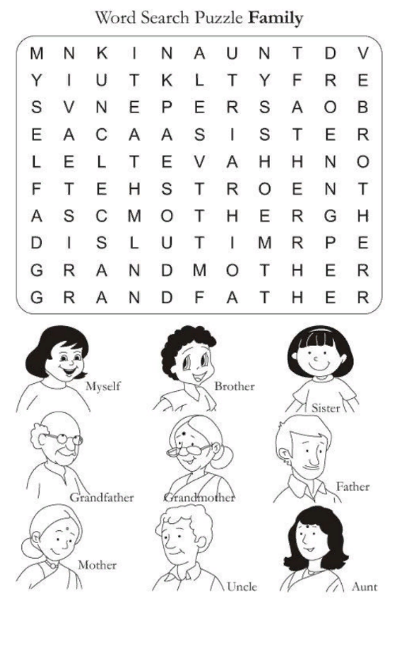
Exersice 3. Прочтите и переведите текст.
«I am Sofia and I want to share a story of my family. My family consists of 4 people: my mother, my father, me and my brother. Both my mother and my father save people’s lives. My mother is a doctor, while my father is a firefighter. My mother likes reading. Every evening we sit together and read books. At the same time, my father and my brother likes sport. When it is warm they spend the whole evening playing in the yard. Sometimes they even forget that it is time to go home. When the weather is bad, they watch basketball on TV. We also have lots of relatives. For example, I have an aunt. She is a lawyer and lives in Moscow with my two little cousins. They visit us every summer. I also have two uncles. They both are sailors that’s why we do not meet very often. My grandmothers and grandfathers live in a small village several kilometers away from us. We usually spend the whole summer with them. We play with my sister and cousins outside, go swimming, eat a lot of fruits and have fun. At the weekends my mother and father visit us and we have a family dinner. We share stories and enjoy our time together. I adore my big and friendly family».
Exercise 4. “AGE” MULTIPLE- CHOICE QUIZ.
A / an ___________________is a very young human between six months and two years age.
A) infant B) pre-school child C) teen D) youth
A ______________________ is a baby who has been recently born.
A) youth B) newborn C) toddler D) teenager
A / an __________________ is an older child whose age ranges between 13 to 19.
A) teenager B) adult C) toddler D)infant
A / an__________________ person is an adult who is not very old.
elderly B) senior C) middle-aged D) old
A / an ________________ is a young child whose age ranges between one and three years old.
A) teen B) senior C) youth D) toddler
I can’t imagine that our mother is celebrating her fifty second birthday! She looks so young, but she is already in her ________ .
A) mid-fifties B) sixties C) late forties D) early fifties
A / an ______________ is a young person who can’t vote on the election.
A) junior B) senior C) underage D) teen
People who are over 65 years are called __________ people.
young B) middle-aged C) elderly D) toddler
The ____________ are people between 40 and 60.
A) elderly B) old C) senior D) middle-aged
A /an ____________ is a person who is usually 21 years old.
A) infant B) adult C) man D) teen
Exercise 5. Составьте текст, используя предложенные слова: mother, English, housewife, village, little, professor, student, lectures, makes, does not, studies, name, does.
The boy’s 1._________ is Jerome. He is an 2._________ schoolboy. He lives in a small 3. _______ not far from London. His 4.________ doesn’t work. She is a 5. ____________ . She 6. ___________ the house, 7._____________ breakfast, dinner and supper. Jerome’s father is a 8.__________. He 9. _____________ at University. Jerome’s brother is a 10.__________ . He 11.____________ at Oxford University. Jerome’s sister is a 12.___________ girl. Her name is Bell. Bell 13._____________ go to school yet, she is only four. Jerome loves his family.
Exercise 6. Расположите слова в порядке увеличения возраста.
Youth, newborn, toddler, teenager, infant, elderly, as ols as hills, senior, middle-aged, underage

