Примечание: 1. На начало занятия здороваемся и ставим + и ФИО (это вы отметились, например, Здравствуйте+ФИО, Доброе утро+ ФИО, Good day+ ФИО и т.д.) 2. Записываем дату (In English!!!) и тему занятия (ОБЯЗАТЕЛЬНО). 3. Внимательно читаем задание и выполняем то, что сказано, письменно, от руки, кстати, я принимаю задания до 16:00 в день пары. 4. В конце каждого листа пишем ФИО (свои) и ставим подпись (свою). 5. Фотографируем и отправляем в ЛИЧНЫЕ сообщения, в группе НИЧЕГО выставлять не надо. 6. Прощаемся и помним: мы встретимся в очном режиме (Если тетрадь, то хорошо, а если листы, то сохраняем).

The 14 th of December.
My family.
Повторение изученного материала
Exercise 1. Заполните пропуски притяжательными местоимениями. Цифра-притяжательное местоимение.
- Nick has a dog. . . .dog is clever (умный).
- Have you got a room? Is . . . room big?
- Ann has a lamp. Is it ... lamp?
- I have a book. . . . book is interesting.
- They have a good room. Is . . . room big?
- This is my mum. … name's Jess.
- These are my sisters. … names are Mary and Dina.
- These are my parents. … names are Tanya and Bob
- This is my cousin. … name's Helen.
- This is my cousin. … name's Fred
- These are my sisters. … names are Tina and Nina.
- This is my aunt. name's Pam.
- She is doing … homework.
- We have … English lesson in the evening.
- He is putting on … rain-coat.
- I often do … homework with … friend.
- This lady’s surname is Smith. What’s … first name?
- Please sit down. Is it … document?
- They do … morning exercises in the open air.
- This table is too small. What’s … length
Изучение нового материала
Exercise 2. Подберите правильный вариант ответа. Цифра-буква
1.Olga is is your mother's mother. Olga is your...
a) mother b) aunt c) granny d) sister
2. Max is your uncle's son. He is your...
a) nephew b) cousin c) twin d) grandson
3. Sarah is your grandma's only daughter. Sarah is your...
a) mother b) aunt c) granny d) sister
4. Nikita is your mother's son. He is your...
a) nephew b) dad c) brother d) grandson
5. Mary is your uncle's wife. She is your...
b) mother b) aunt c) granny d) sister
Exercise 3. Вставьте подходящие названия родственников на английском.
- Nick is your mother's husband. He is your ...
- Alex is your brother's son. He is your ...
- Your mother and father are your ...
- Patrick is your father's brother. He is your ...
- Sheena is your father's daughter. She is your ...
Exercise 4. Скажите, верны ли предложения (True or False), используя FAMILY TREE. Исправьте неверные предложения.
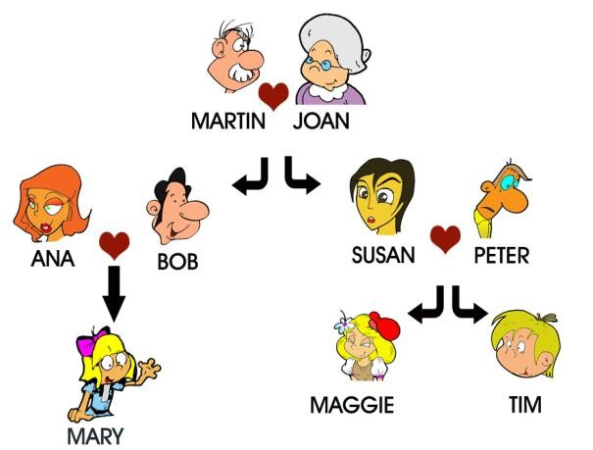
- Susan is Maggie's mother.
- Martin is Tim's father.
- Peter is Mary's uncle.
- Joan is Maggie's granny.
- Maggie is Tim's brother.
- Bob is Ana's husband.
- Mary is Maggie's cousin.
- Mary is Peter's niece.
- Peter is Tim's granddad.
- Susan is Martin's daughter.
- Tim is Susan's daughter.
- Ana is Bob's aunt .
- Ana and Bob are Mary's parents.
Exercise 5. Заполните таблицу, используя следующие слова
Brother, children, aunt, grandfather, grandparents, grandmother, father, husband, mother, nephew, niece, son, wife, sister, uncle, grandson, aunt, granddaughter, parents, cousins, great grandparents

MEN (мужчины) | WOMEN (женщины) | PLURAL (множественное число)
Exercise 6. Прочитайте текст о семье и заполните таблицу.
He is John Shinder. He is from London, England. He is forty-two years old He is a photographer. He is tall and slim. His eyes are brown and his hair is black. He is married. His wife is Alice Shinder. She is from Liverpool, England. She is a teacher. She is forty years old. She is not very tall and slim. Her eyes are blue and her hair is long and dark. Their children are Max and Kate. They are eleven years old. They are twins. John loves taking photos and Alice loves reading romantic books. They have got two lovely cats.
Husband | Wife
Full name:  Age:  Country:  Hometown:  Job:  Eyes:  Hair:  Hobby: | Full name:  Age:  Country:  Hometown:  Job:  Eyes:  Hair:  Hobby:
Exercise 7. Дополните текст о семье правильной формой глагола (PRESENT SIMPLE). Текст не переписывайте, запишите только правильную форму глагола)
Hi! My name is Kate. I (1) ___________ (live/lives) with my parents in Sydney, Australia. My mother’s name is Nancy and my father’s name is Patrick. I (2) __________ (have/haves/has) two brothers and one sister.
My brothers, Landon and Shamus, (3) ____________ (live/lives) with us. Landon (4) ___________ (study/studies) at school. He (5) _____________ (take/takes) the train to school. He (6) ____________ (get up/gets up/get ups) at 6 am. That’s very early! But Shamus (7) ________________ (get up/gets up/get ups) late. He (8) ______________ (walk/walks) to work. Landon (9) ________________ (do/dos/does) his homework every day at 5pm.
My sister, Alice, (10) _____________ (live/lives) downtown with her husband, Tod. He (11) ______________ (work/works) in the suburbs. Tod is a doctor, but he (12) ______________ (don’t work/doesn’t work/doesn’t works) in a hospital, he (13) _____________ (work/works/workes) in an office. They (14) ______________ (visit/visits/visites) us every Sunday.
I really (15) __________________ (love/loves) my family!

