The 15th of December
Topic: Hobbies
- Today we’re going to talk about hobbies and free time activities.
What free time activities do you know. Read and remember:
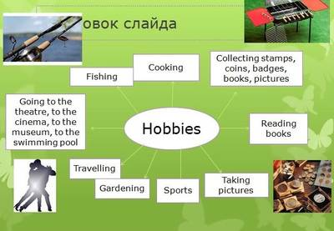

Free time activities:
Reading
Painting
Watching TV
Listening to music
Surfing the internet
Playing games
Taking photos
Talking on the phone
Watching videos
Cooking
Swimming
Going to the beach
Surfing
Camping
Fishing
Playing tennis
Skateboarding
Riding a bike\ cycling
Riding a horse
Jogging
Hiking
Doing exercise
Rock climbing
Sightseeing
Going out with friends
Going to a concert
Going to the cinema
Playing the guitar
Singing
Dancing
Going shopping
Playing cards
Doing crosswords
Doing puzzles

- match the proverbs and their translations
- 1.Variety is the spice of life.  - 2.There is no accounting for tastes.  - 3.Business before pleasure.  - 4.Tastes differ.  - 5.Many men, many minds. | a.Делу время потехе час.  b.О вкусах не спорят.  c.Вкусы невозможно объяснить.  e.Сколько людей, столько и мнений.  f.Вкус жизни в разнообразии.
3. Чтение и перевод текста Leisure. Entertainment.
Leisure. Entertainment.
Nowadays everybody knows that people are very busy and don’t have much spare time. The English say: "Who knows how to work, knows how to rest". Rest is as important as work.
Some people prefer spending their free time with their family and friends; some prefer spending their spare time alone.
Young people like going to the cinema, theatre, disco clubs, concert halls.
There are people who want to broaden and enrich their knowledge during their free time. They spend their free time reading books. They can go to the museums, picture galleries where they can see the works of well-known painters and sculptors of all times. If people want to be strong and healthy, they go in for sports. There are many sports clubs, swimming pools, and gyms for everybody who loves sports. Sport will make you not only healthier and stronger, but kinder, more sociable and cheerful. Sport will give you its strength and energy.
Moreover, there are a lot of people, who prefer less energetic activities, such as chess, cards, and crosswords. . There are so many hobbies to choose: painting, computer programming, photography, fishing, gardening, cooking, learning languages, collecting something.
Tastes differ and if you have chosen a hobby according to your character and taste you are lucky. Travelling is also a good way to spend spare time. Visiting new places, sightsseeing and meeting new people is a very exciting and useful relaxation. People can go hiking, camping. Each person chooses his own way of spending free time, either passive or active. In any case leisure should be refreshment and a source of inspiration.
4. Составление плана текста.
5. Поиск английских эквивалентов предложений в тексте.
Find English equivalents of these sentences in the text:
1. Существует так много хобби, которые можно выбрать: рисование, компьютерное программирование, фотография, рыбалка, садоводство, приготовление еды, изучение иностранных языков, коллекционирование чего-либо.
2.Для всех, кто любит спорт есть много спортивных клубов, бассейнов и спортзалов.
3. Путешествие - это также хороший способ провести свободное время.
4. Молодые люди любят ходить в кинотеатры, театры, дискоклубы, концертные залы.
5. Если люди хотят быть сильными и здоровыми , они занимаются спортом.
6. Они проводят свое время, читая книги.
7. Они могут пойти в музеи, картинные галереи , где могут увидеть работы известных художников и скульпторов всех времен.
6. Аудирование: прослушивание аудиозаписи песни «The hobby song» https://www.youtube.com/watch?v=PmRb_W7NuZ8 , заполнение в предложениях из песни отсутствующих слов, контроль понимания.
«The hobby song»
My family isn’t at work today  It’s Sunday. We are free  We’re all off work. Having fun  Doing a hobby  My girlfriend’s in the kitchen  She’s taken up cookery  But she promised me  to play computer games  after dinner at three  Granddad’s playing cards again  and watching movies on TV  Grandma’s knitting and sewing,  reading a book on her knee  Mom’s gone down to the woods today, painting a picture of a tree | And Father’s in his woodworking shed,  He’ll be finished at 5:30  My sister’s gone off hiking  with her best friend Beverley  And her boyfriend’s gone out biking  He said it wasn’t too windy  My brother’s gone away camping  He won’t be bothering me  Because my hobby’s playing music really loud  I love that melody!  My family isn’t at work today  It’s Sunday. We are free  We’re all off work.Having fun  Doing our favourite hobbies

Т. Now Сomplete the missing words:
My family isn’t 1)_________today  It’s Sunday. We are 2)_________  We’re all off work. Having 3)______  Doing a hobby. My girlfriend’s in the 4)__________  She’s taken up 5)___________.  But she promised me to play computer games after 6)________ at three 7)____________playing cards again  and watching movies on TV 8)___________knitting and sewing,  reading a book on her knee 9)____ gone down to the woods today, painting a picture of a tree. And 10)______ in his woodworking shed, He’ll be finished at 5:30 11)__________gone off hiking  with her best friend Beverley. And her 12)________ gone out biking. He said it wasn’t too windy 13)___________gone away camping.He won’t be bothering me Because my hobby’s playing music really loud. I love that 14)___________!  My family isn’t 15)_________today  It’s Sunday. We are 16)_______  We’re all off work. Having 17)______  Doing our 18____________hobbies. | - Mom’s  - Kitchen  - Dinner  - Father’s  - Melody  - My brother’s  - Granddad’s  - My sister’s  - at work  - cookery  - favourite  - Grandma’s  boyfriend’s  - fun  - free  - at work  - free  - fun
2. Просмотр презентации по теме урока. https://www.youtube.com/watch?v=NKEu_oq1qc0
- Заполнение таблицы «Виды хобби».
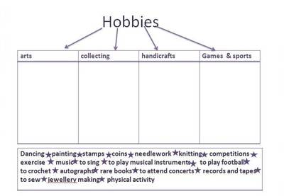

Answer the questions about your free time activities:
1.What activities do you like doing in your free time?
I love …I really like… I like … I don’t like … I hate …
2. What films do you prefer?
Comedy, Drama, Horror, Thriller, Action, Science Fiction (Sci-Fi), Fantasy, Documentary, Musical.
3.Do you watch TV?
Yes,every day; sometimes; seldom; no, never
4.What programs do you prefer?
The News, Soap Operas, Criminal Investigation Dramas, Medical Dramas, Reality TV, Situation Comedies (Sit-Coms), Talk Shows, Documentaries, Cartoons, Game Shows, Sports programs, Movies, Political programs, Religious programs.
5.How many hours a day do you spend using the internet?
6.Do you play video games?
Yes,every day; sometimes; seldom; no, never
7.Can you play any musical instruments? (What musical instrument?)
8.Do you like going to the museums\ theatres?
9. What foreign languages can you speak?
10. Can you cook?
11. Do you like going shopping?
12. Do you like sport? What sport do you like? What sport can you play?
13. Do you keep fit? Do you go to the gym?
14. Can you ski, skate?
15. Do you like travelling? What place would you like to visit?

